2.5-1) Consider a microphone intended for use in a music recording studio. Determine a suitable frequency response for the microphone, and provide suitable values to specify the response.

First, some info

* Human hearing is in the range of 20Hz 🡪 20kHz
* Humans “readily perceive amplitude distortion, but are relatively insensitive to phase distortion”

What this means

* We should definetly pass 20Hz 🡪 20kHz.
* The pass-band ripple should be very low

An ideal frequency response for a microphone would be a “pulse” with a pass-band from 20Hz to 20kHz with a gain of 1. If we are talking a non-ideal world, then I would think something that has little pass-band ripple and covers the whole frequency range would be good.

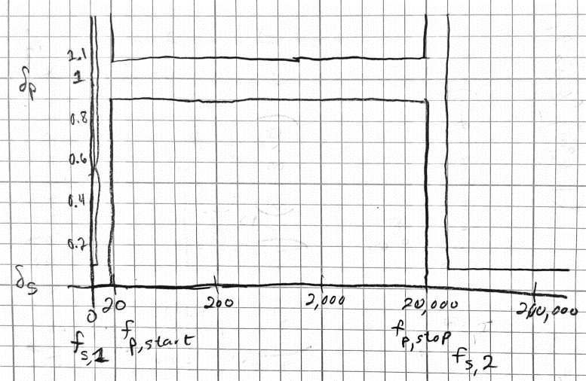

$δ_{p}=0.9→1.0$, $δ_{s}=0→0.1$

$$f_{s,1}=10Hz f_{s,2}=22,000Hz$$

$$f_{p,start}=20Hz f_{p,stop}=20,000Hz$$